***3 Days 2 Nights Kuching & Annah Rais Bidayuh Longhouse Package***

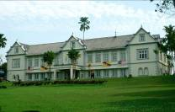 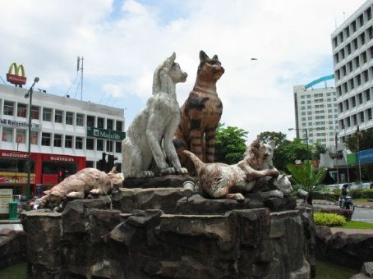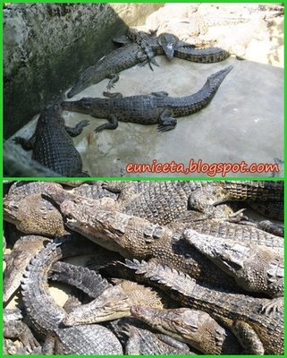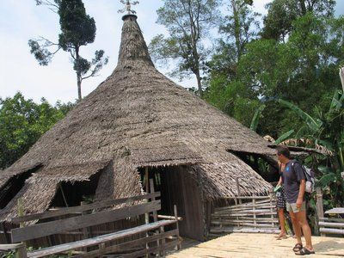

|  |  |  |  |  |  |
| --- | --- | --- | --- | --- | --- |
| **Package Rate per pax (RM)**  **Room based on R.O.H.** | | **2 - 3 pax**  **~ seat-in-coach ~** | | **4 – 7 pax**  **~ seat-in-coach ~** | |
| **Twin/Triple** | **Single** | **Twin/Triple** | **Single** |
| 3* Telang Usan or similar | | 485.00 | 600.00 | 425.00 | 550.00 |
| 3* Kuching Park / Kingwood Inn | | 495.00 | 620.00 | 440.00 | 560.00 |
| 4* Grand Margherita Hotel | | 590.00 | 810.00 | 540.00 | 750.00 |
| 4* Merdeka Palace / Four Point | | 555.00 | 740.00 | 495.00 | 680.00 |
| 5* Hilton Kuching | | 655.00 | 950.00 | 595.00 | 880.00 |
| 5* Pullman Kuching | | 660.00 | 950.00 | 600.00 | 890.00 |
| **~ Child with ½ share twin room @ 90% of adult rate.**  **~ Child with extra bed @ 80% of adult rate.**  **~ Child without bed @ 60% of adult rate** | | | | | |
| **PACKAGE INCLUDES :** | ~ 2 Night accommodation at City Hotel of your choice.  ~ 2 Breakfast, 1Lunch, 1 Dinner.  ~Guided Kuching City tour , Semenggoh Orang Utan , Crocodile farm , Annah rais Bidayuh Longhouse &  Sarawal Pottery Factory . ( all guided tour are included entrance fees)  ~ Airport – Hotel / Resort – Aiprort Return Transfer.  ~ Experienced English / Mandarin / B.M. speaking guide. (RQ before arrival) | | | | |
| **PACKAGE EXCLUDED :** | ~ Airfare & Airport Taxes.  ~ Suggested Tipping for guide/driver @ min RM 5.00 per pax per day.  ~ Optional Tour.  ~ Travel Insurance & Personal MISC Expenses.  ~ Peak Season Surcharge during 20 – 31 Dec 2011 , 01 – 02 Jan 2012 & 22 – 25 Jan 2012 . ( RATE TBA) | | | | |

**Itinerary :**

**Day 01 Airport – Kuching City & Shopping Tour (D)**

Arrival Kuching airport , meet & greet , transfer to Kuching City & Shopping Tour . Visit : Ornate Chinese Temple ,

The Astana , City Tower , Sarawak Muzeum , Cat Muzeum , Main Bazaar , China Town , Old State Mosque . After that

Proceed to Homemade Kek Lapis . The Sarawak layer cake is a well-loved local delicary that laborious & intricate to make

But so delicious to eat . Kuching is a good destination to shop for souvenir such as woodcarvings ,”Pua Kumbu” with native

Design , pepper products & Sawarak Pottery. After tour , transfer back to hotel , free at own leisure .

**Day 02 Semenggoh – Crocodile Farm-Annah Rais Bidayuh Longhouse – Sarawak pottery Factory (B,L,D)**

Hotel breakfast . Morning proceed to visit Semenggoh Nature Reserve.Unlike in a Zoo , the orang utans are set free

In a 653-hectare forest reserve. Here , young Orang utans , who were either orphaned from captivity , are trained to

Survice in the wild.Continue the journey to visit Crocodile Farm & Mini Zoo . The farm set amidst tropical fruite trees

And lush-greenery in a home to over 1,000 crocodiles.Lunch is provided . After lunch , proceed to visit Annah Rais

Bidayuh Longhouse.Enroute stop over at Sarawak Pottery Factory . This is a chance for you to get a typical Sarawak

Ceramic & native handicraft to bring back as a souvenir . After tour , transfer back to hotel , free at leisure.

**Day 03 DEPARTURE – KUCHING AIRPORT (B)**

Hotel breakfast, free at leisure till transfer to airport for your departure.

**Notes :**

1. The above rate are subject to acceptance of resort’s term & conditions of contracts.
2. The Hotel reserves all rights to revise the contracted rates without prior notice.
3. Validity : Until 31 March 2012.
4. All rate quoted is based on RINGGIT MALAYSIA.